Theme Symposia For RSSDI-2018
All the RSSDI members are invited to collect original clinical data as per the following themes which can be presented at the 46th Annual Conference of RSSDI 2018 on 23-25 Nov 2018 at Ahmedabad.
- Prof. MMS Ahuja Symposium - "- Population Specific Characteristics of Diabetes in India."
- Prof. B.B. Tripathi Nutrition symposium - " Dietary Carbohydrate Consumption in Diabetes Patients and Normal Individuals"
The last Date for Abstract submission is 31st August 2018.

Address of Email of Scientific Chair 2018 -

Dr Rajeev Chawla
Scientific Chair RSSDI 2018
180 Jai Apartment Sec-9 Rohini,
New Delhi-110085.
Tel: +91-11-27563814,Fax: +91-11-47045282
Mobile: +91-9811799666
Email: scientificrssdi2018@gmail.com

RSSDI THERAPEUTIC WHEEL
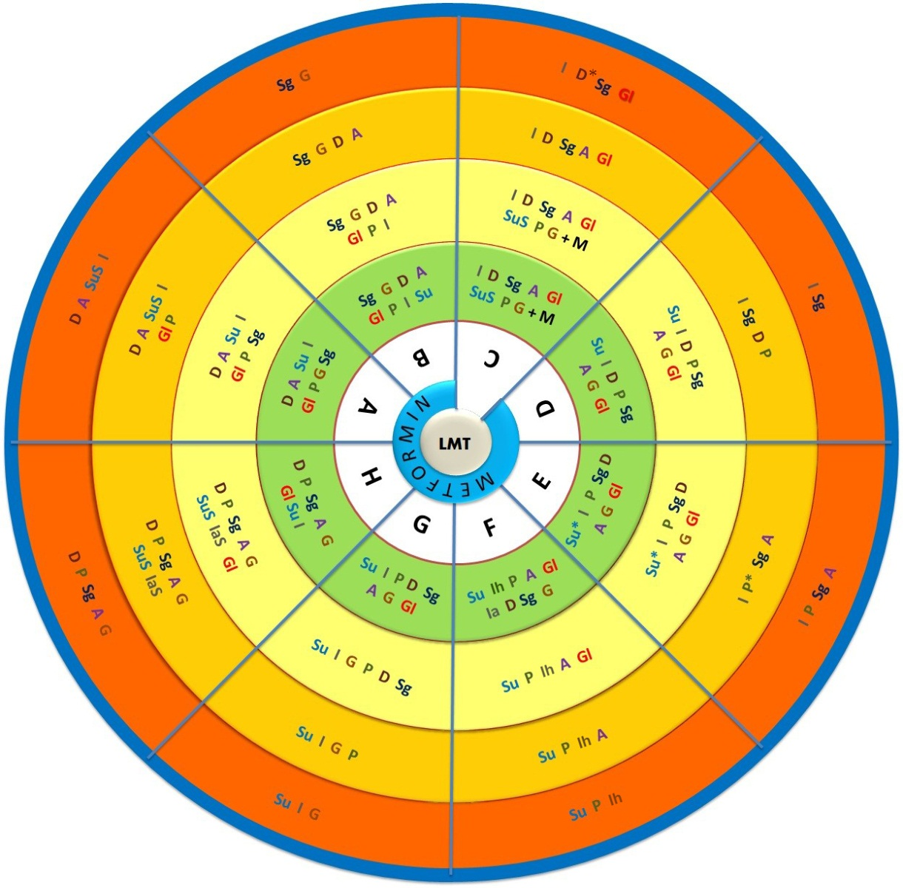
Su – Sulfonyl Urea
Su* - Preferably Glimiperide or Gliclazide
SuS – Short acting Sulfonyl ureas
I – Insulin
Ih – Human Insulins
Ia – Insulin Analogues
IaS – Short Acting Insulin analogues
D – DPP4 inhibitors
D* Dose adjustment for linagliptin teneligliptin and gemigliptin is not required
P – Pioglitazone
P* - Pioglitazone if EF > 40%
Sg – SGLT2 Inhibitors
A – Alphaglucosidase Inhibitors
G – GLP Analogues
Gl – Glinides
From Innermost to Outermost : A Age = Advancing Age; B BMI = Increasing BMI; C CKD = Advancing CKD; D Duration of Diabetes = Increasing Duration; E Established CVD = Low CVD risk to Established CVD Risk; F Finance = Adequate to Limited; G Glycaemic Status = Worsening glycaemic control; H Hypoglycemia = Hypoglycaemia concern

Note: Hydroxychlorquinone has recently been approved by DCGI for the treatment of T2DM as third line therapy;
SGLT2 inhibitors are recommended in patients with high CV risk

